Online Food Delivery: Customer Feedback Analysis

Overview
This project analyzes an online food delivery dataset to find out **which customer segments give negative feedback**, and whether those patterns are statistically real or just chance.
It covers data cleaning, exploratory data analysis (EDA), hypothesis testing (chi-square), and an interactive Power BI dashboard.

Business question: Which customer groups (by income, age, marital status, gender) are most likely to leave negative feedback, and what should the company do about it?

Project Structure

├── online food delivery dataset.csv # Original dataset
├──correct online food delivery dataset.csv.csv # Cleaned dataset (with Income_Rank, Gender_Clean)
├── onlinefood.py / .# Python cleaning, EDA and chi-square tests
├── Statistical Analysis.xlsx # Excel verification of chi-square test (optional)
├── Online Food Delivery.pbix # Power BI dashboard
├── Dashboard img.png # Dashboard screenshot
├── README.md # Project documentation

Dataset
388 customers, all based in the Bangalore area
Columns: Age, Gender, Marital Status, Occupation, Monthly Income, Educational Qualifications, Family size, Customer Type, latitude, longitude, Pin code, Output (reorder: Yes/No), Feedback (Positive/Negative), Corrected_Label
Class balance: 81.7% Positive vs 18.3% Negative feedback; 77.6% "Yes" vs 22.4% "No" for reorder
Profile: young (average age 24.6), student-dominated (53%), highly educated (90%+ Graduate or Post Graduate)

Installation
1️⃣ Clone the repository:

2️⃣ Install dependencies:
pip install pandas
numpy
matplotlib
scipy
3️⃣ Open the Power BI file (`Online Food Delivery.pbix`) in Power BI Desktop to explore the dashboard.
Methodology
Data Cleaning
- Fixed the mismatch between the Feedback and Label columns (Corrected_Label) - Converted columns to correct data types (numeric vs text) - Checked for missing values (none found) and impossible values (none found in Age, Family size, coordinates, Pin code) –
- Standardized Gender categories (including "Prefer not to say" as a separate "Undisclosed" group) - Encoded Monthly Income as an ordered rank (No Income = 0 up to More than 50000 = 4), treating "No Income" as a valid category, not missing data
Exploratory Data Analysis (EDA)
Summary statistics with `info()` and `describe()` - Category counts with `value_counts()` - Cross-tabulations of Feedback against Occupation, Income, Education, Customer Type, Marital Status, Gender and Age Group - Age grouped into Under 20, 21-25, 26-30, 31-40
Statistical Testing ChiSQTest
square tests of independence between each factor and Feedback (significance level 0.05). Results were verified in both**Python (scipy)** and **Excel (CHISQ.TEST)**. Age was tested as age groups rather than individual ages, because individual ages produced expected counts below 5, which makes the chi-square test unreliable.
Dashboard
Built a Power BI dashboard with DAX measures for Positive Feedback Count, Negative Feedback % and Reorder Rate, plus 100% stacked bar charts of feedback by income, marital status and age group.
📈 Key Findings
| Factor | Result | Significant? |
|---|---|---|
| Monthly Income | p = 0.0000080 | ✅ Yes |
| Age Group | p = 0.0000434 | ✅ Yes |
| Marital Status | p < 0.05 | ✅ Yes |
| Gender | p = 0.3 | ❌ No |
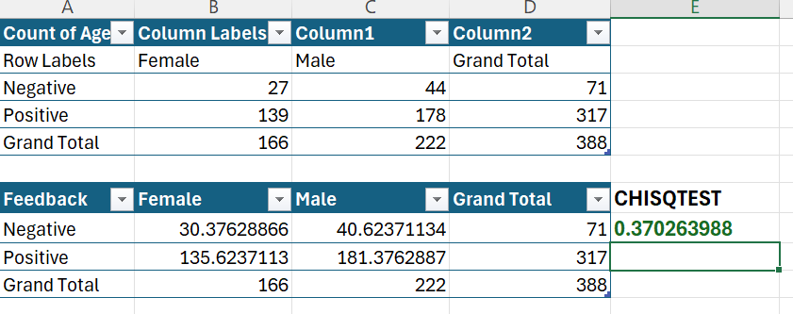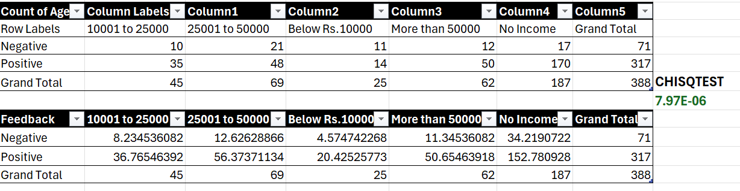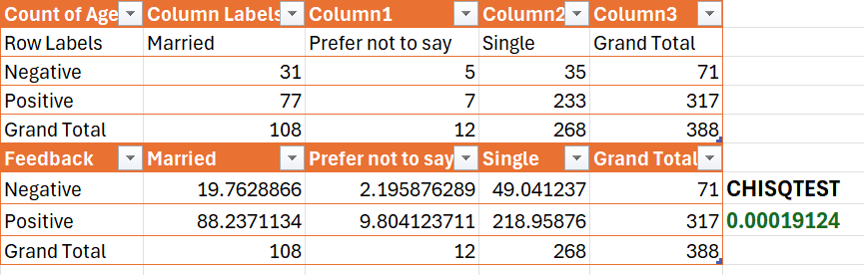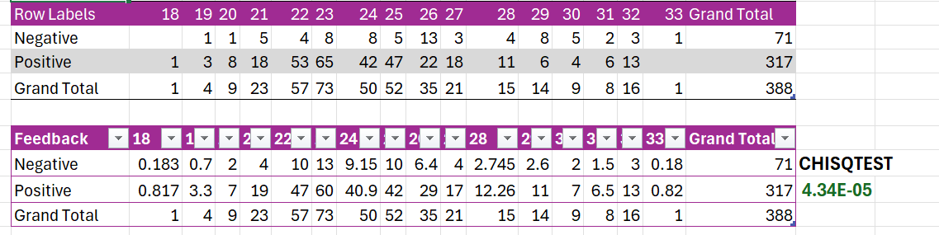
Income: "Below Rs.10000" customers had the highest negative feedback (44%), while "No Income" customers (mostly students) had the lowest (9%).

Age:The 26-30 group was the least satisfied (35% negative), while the 21-25 group was the most satisfied (12%).

Marital status: Married customers gave more negative feedback (28.7%) than single customers (13.1%).

Gender: No statistically meaningful difference between male and female customers.

Note on small samples: Some groups are very small (Uneducated = 2, House wife = 9, Prefer not to say = 12), so percentages for these groups should not be treated as reliable conclusions.
Business Recommendations
Run targeted satisfaction surveys for the 26-30 age group and low-income customers to identify their specific pain points (delivery time, pricing, portion size, quality). - Consider budget-friendly combos or loyalty offers for the "Below Rs.10000" income segment. - Improve family-size or bulk-order options for married customers. - Treat the reasons above as hypotheses to test, since this dataset shows *who* is dissatisfied but not *why*.
Dashboard Preview (Dashboard img.png)
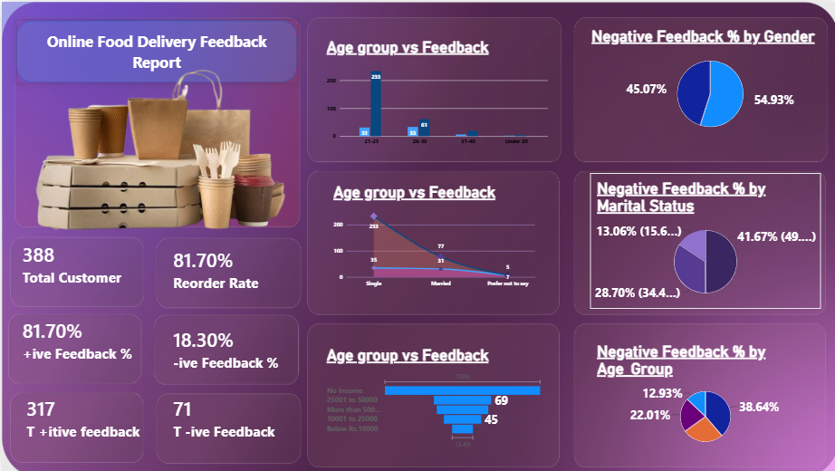
Technologies Used –
Python (Pandas, NumPy, Matplotlib, SciPy) –
Microsoft Excel (Pivot Tables, CHISQ.TEST) –
Power BI Desktop (DAX) –
Jupyter Notebook / VS Code
Future Improvements - Build a machine learning model to predict negative feedback and reorder likelihood - Add the relationship between negative feedback and reorder intention (Feedback vs Output) as a deeper analysis - Use a larger or more varied dataset (this one covers only one city and mostly students) - Add customer comments or text data for sentiment analysis

